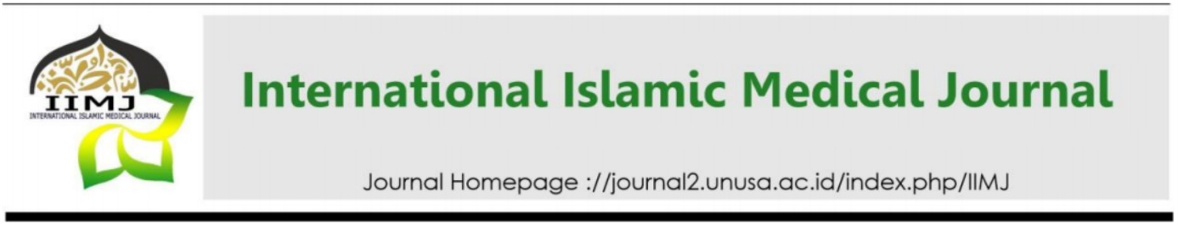
Title Max 20 Words: Instructions/Template for Preparing Review Manuscript for IIMJ (Times New Roman 16, Bold, Capitalize Each Word, and Align Left)

First Author,^{1*} Second Author²

¹Affiliation (Name of Department, Name of Faculty, Name of University, Name of City, Name of Country)
²Affiliation (Name of Department, Name of Faculty, Name of University, Name of City, Name of Country)
*Corresponding Author: xxxx@xxx (Times New Roman 10, Singled Spacing, Align Left)

ARTICLE INFO |  | ABSTRACT
Keywords:  (3-5 words and/or phrases)  Submitted:  Reviewed:  Accepted: |  | The abstract should be in one paragraph. The font is Times New Roman, 10 pt, and justify. Abstract is in 250-350 words, which is followed by 3-5 keywords. The abstract should briefly describe your entire paper. Consists of Background, Results, and Conclusions

Introduction (Font size: 12, Times New Roman, bold, and Capitalize Each Word)
State the objectives of your topic and provide an adequate background, avoiding a detailed literature survey or a summary of the results. Explicitly state the urgencies, which signifies the significance of your topic. (Times New Roman 12, 1.5 spacing, justify)

Results
The result is written to interpret and describe the significance of your topic review, and to explain any new understanding or insights about the problem. In this section write detailed explanations that are subtopics related to the topic. Topic can also be supported with the presentation of tables, images, etc. Captions for table is written above it with sequenced numbering so that it can be easily referenced.

Conclusion
The conclusion is intended to summarize the topic described in this article. It helps the readers understand why your topic should matter to them after they have finished reading the paper. It should be consist a synthesis of key points and able to reflect the main point of the article.

References (IIMJ uses APA 7th referencing style. The references should be in alphabetical order, Use Times New Roman (12)
Sarkar, S., Patra, C., Dasgupta, MK et al., 2013. Prevalence of Congenital Anomalies in Neonates and Associated Risk Factors in a Tertiary Care Hospital in Eastern India. J Clin Neonatol. Jul-Sep; 2(3): 131–134.
Thaddanee, R., Patel, HS., Thakor, N., 2016. A Study on Incidence of Congenital Anomalies in Newborns and The Association with Maternal Factors: A Prospective Study. Int J Contemp Pediatr 3. (2):579-582

