Title: Modification of Research Objectives

Abstract
Keywords: Keyword1, Keyword2, Keyword3, Keyword4, and Keyword5

1. Introduction
Paragraph 1: Tell us about the importance of this topic to one of [Science, society, or technology]
Paragraph 2: Tell us what previous research has done, either chronologically or grouping
Paragraph 3: Tell us what are the obstacles/ gaps/ weaknesses of previous research
Paragraph 4: The purpose and significance of this research

2. Materials and Method
2.1 Materials
If the research topic is correlation or other quantitative research, then write down all the research respondents and their characteristics. If the topic is technology, you can write down the location of the research or where the secondary data used was obtained.

2.2 Data collection procedures
Write in full how the analyzed data was obtained. Or write down how the experiment was carried out or write down how the sampling was done. Don't forget to write references.

2.3 Data analysis procedures
Write in full how the data that has been collected is analyzed to answer the objectives. Narrate sequentially in paragraph form. Don't forget to write references.

3. Results and Discussion

3.1 Topic 1

Explain clearly the results and discussions that have been obtained in the following format: (i) what is this?, (ii) what is the data pattern like [try to be detailed]?, (iii) explain why the data pattern is like that [try to be detailed], and ( iv) compare with previous research.

Example of Table and Figure

Demographic characteristics and descriptive statistics
A total of 1004 Indonesian undergraduate-level students attending university in East Java, Indonesia, participated in the research study. Table 3 shows the demographics, the statistics of age variables in different subcultures, gender, field of sciences, and years of formal education.
Table 3. Socio-demographic details of respondents
 | n (%) | Age
 |  | Range | mean ± SD
Respondents by subcultures
Arek | 528 (52.59%) | 15-30 | 20.91 ± 2.51
Madura | 140 (13.94%) | 17-30 | 20.62 ± 2.03
Matraman | 221 (22.02%) | 18-30 | 20.57 ± 2.13
Pandalungan | 115 (11.45%) | 18-27 | 20.73 ± 1.50
Respondents by gender
Male | 251 (25%) | 15-30 | 21.77 ± 2.27
Female | 753 (75%) | 15-30 | 20.77 ± 2.27
Respondents by the field of science
Health Sciences | 197 (19.62%) | 15-30 | 20.58 ± 2.18
Education | 415 (41.33%) | 18-30 | 20.99 ± 2.45
Social Sciences | 190 (18.92%) | 18-30 | 20.65 ± 2.22
Mathematic and Natural Science | 35 (3.49%) | 18-27 | 20.83 ± 1.79
Engineering | 167 (16.63%) | 17-30 | 20.52 ± 2.02
Respondents by years of completing formal education
13 years | 284 (28.29%) | 15-30 | 20.45 ± 1.89
14 years | 296 (29.48%) | 18-30 | 20.83 ± 2.25
15 years | 278 (27.69%) | 18-30 | 20.71 ± 2.15
16 years | 146 (14.54%) | 18-30 | 21.40 ± 2.99

Arek Data | 0,904
Madura Data | 0,9
Matraman Data | 0,964
Pandalungan Data | 0.659
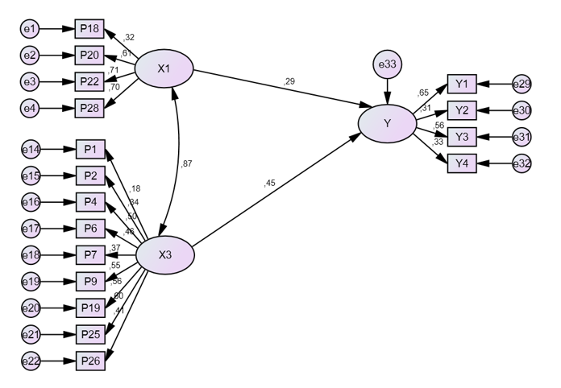
Fig. 1. Standardized total effects of meaning of purpose (X1) and interconnectedness (X3) to empathy (Y).
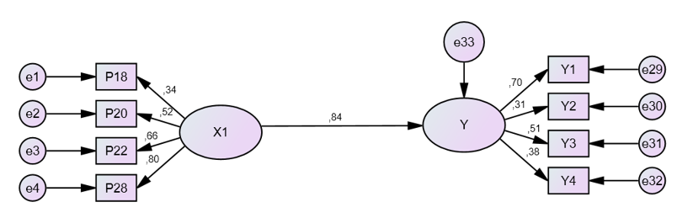
4. Conclusion
Rewrite the objective so that it reminds the reader what has been done (1 sentence). Convey results according to specific objectives (3-4 sentences). The impact and significance are conveyed (1 sentence). Recommendations for further research (1 sentence)

Reference
Use APA style. We recommend using reference management such as EndNote, Mendeley, etc.

